

CT问卷网

Review meeting

Review meeting

Date | 2014.7.5 |  |  | Place | 317
Comparison actual with planning for this iteration
Story ID | task |  |  | people | Estimated |  | Actual
1 | register and login design and test |  |  | 吕志宏、李明远 | 5 |  | 5
2 | create a questionnaire,about the subject,UI design and test |  |  | 闪硕、王成真 | 8 |  | 12
3 | create a questionnaire,about question content,UI and function design and test |  |  | 闪硕、王成真 | 9 |  | 9
5 | Release the questionnaire, function design and test |  |  | 赵付涛、黄海亮 | 2 |  | 5
11 | manage user, function design and test |  |  | 黄海亮、赵付涛 | 5 |  | 5
12 | manage questionnaire,function design and test |  |  | 黄海亮 | 4 |  | 4
13 | statistic the information of the website,function design and test |  |  | 付明霞 | 3 |  | 3
Burning down:
We have finished six user stories ,which sum up to 28 point. And we are preparing to do the user stories we will do in next iteration. This our Story Board and Burning Down Graph:

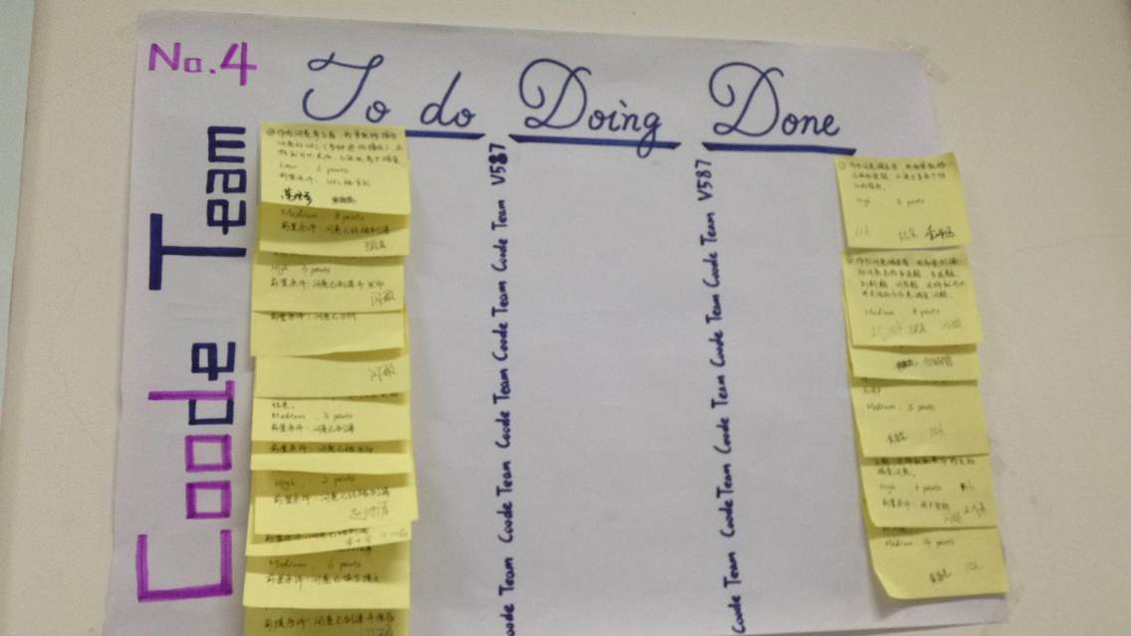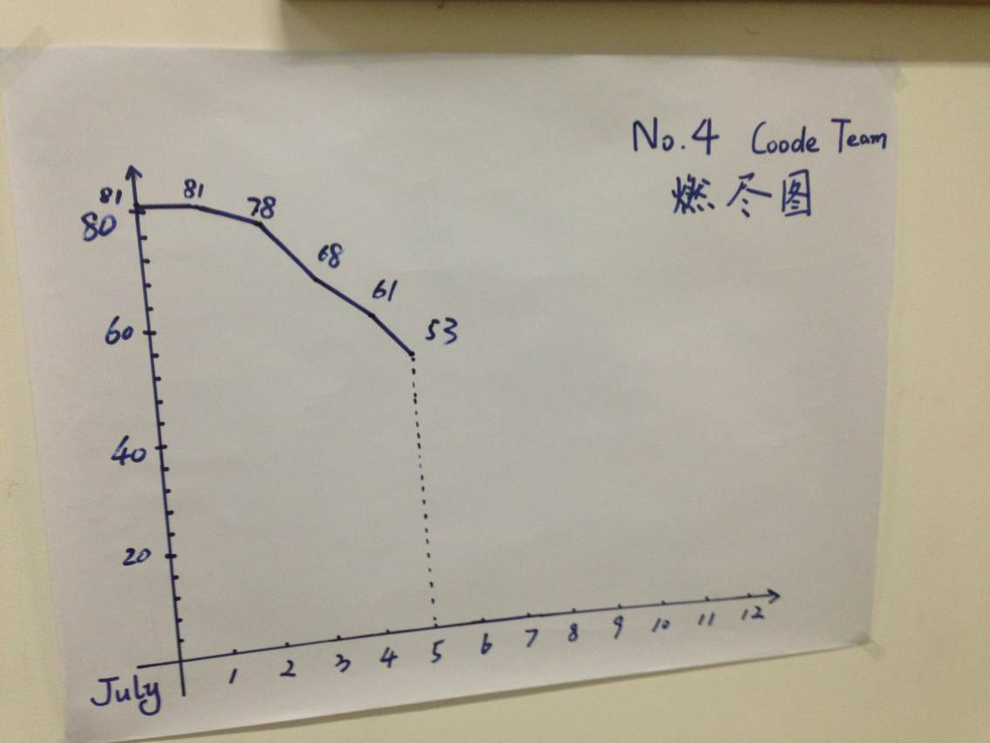
Good things:
Everyone has participanted in this project, and everyone is in great passion. We cooperate well with each other, and we have almost finished the tasks of this iteration in good quality.
Need to improve things:
We need to improve our programming ability; we need to improve our understanding of web projects; we need to improve the design of database to make it more efficent on data processing.
Ideas!
Set up introductive and interactive procedure;
Improve the ability of page jumping;

The adjusted planning for the next iteration
Story ID |  | task | people |  |  | Estimated
5 |  | Release the questionnaire, function design and test | 赵付涛、黄海亮 |  |  | 5

Peer assessment
L1（not exceeding 15%）:4、8
L2(not exceeding 25%）:10、14、1
L3: 2、3、5、6、7、9、11、12、13、15
L4:
L5:

By the way, I think our Feeling Board is the most vivid, it’s owe to Li Mingyuan. He made it by heart. Look at this picture:
